**IANA WHOIS for Domain Information**

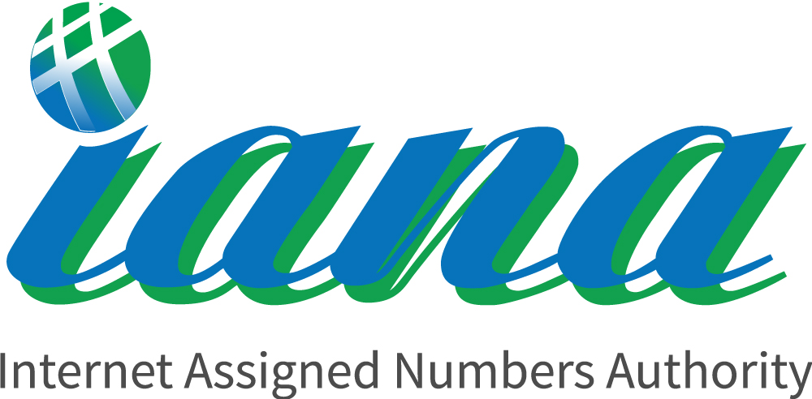

**Introduction**

WHOIS is a protocol used for querying databases to obtain information about the registration of a domain name or IP address. The Internet Assigned Numbers Authority (IANA) provides a WHOIS service that allows you to retrieve details about the registrant of a domain name or IP address. This service is useful for gathering information about domain ownership and registration details.

**Process to Perform**

Step 1: Open the IANA WHOIS Website: <https://www.iana.org/whois>

1. Open your web browser.

2. Navigate to IANA WHOIS: <https://www.iana.org/whois>

3. Enter the domain ““www.islington.edu.np”name to gather information.

**Let's Begin The Challenge**

**Question**

Flag 1: What is the name of the registrant for the domain “Islington.edu.np”?

Answer: Mercantile Communications Pvt. Ltd.

Flag 2: Website created to date?

Answer: 1995-01-25

**Hint**

